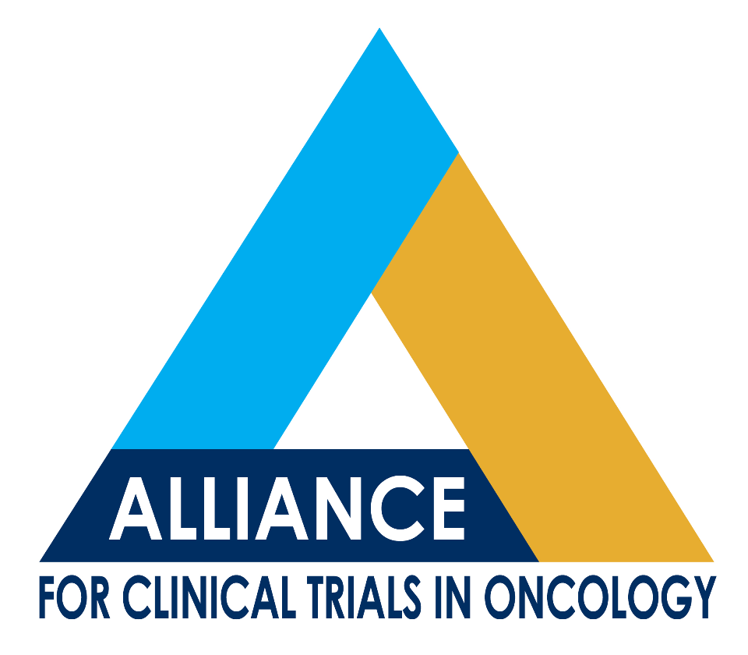
Cancer Control Program
Community Oncology Committee
200 First Street, SW
Rochester, MN 55905
P: 507-266-9202
F: 507-284-1803

www.allianceforclinicaltrialsinoncology.org

Robert J. Behrens, M.D.
Walter R. Peters, Jr., M.D.
Jon F. Strasser, M.D.
Co-Chairs

Agenda
Community Oncology Committee Meeting
Saturday, November 9, 2013
3:00 – 5:00 PM CST
Guggenheim 1/2

Meeting available by teleconference: Dial 800-501-8979 Access Code: 2107872

Meeting available by webconference: log into www.paetec.com/conferencing, click on the "Join a Conference" option, enter 8005018979 followed by the 7-digit access code: 2107872. You will be asked to enter your name, email, phone and company. Only the name is required.

Committee Leadership Members:
Robert J. Behrens, MD | Co-chair | rbehrens@cancercenterofiowa.com
Walter R. Peters, Jr., MD | Co-chair | wpeters@columbiasurgical.com
Jon F. Strasser, MD | Co-chair | jstrasser@christianacare.org
Jan C. Buckner, MD | CCP Program Director and PI | buckner.jan@mayo.edu
Jacqueline M. Lafky, MS | CCP Program Manager | lafky.jacqueline@mayo.edu
Guest Speakers:
Wei Ding, PhD | Judy Hopkins, MD
Matt Facktor, MD | Vicky Seewaldt, MD

- Welcome and Introduction of New Co-Chair (5 minutes)
Walter Peters, MD

- Presentations (20-25 minutes each)
- Prevention Committee Update: What do community oncologists want to see in the prevention arena?
Judy Hopkins, MD

- N1087: Phase I/II Study of the Combination of Bendamustine, Rituximab and MK-2206 in the Treatment of Relapsed Chronic Lymphocytic Leukemia and Small Lymphocytic Lymphoma
Wei Ding, MD, PhD

- A211202: Testing for Atypia in Random Periareolar Fine Needle Aspiration (RPFNA) Cytology After 12 Months Metformin (1,1-Dimethylbiguanide Hydrochloride) Chemoprevention Versus Placebo Control in Premenopausal Women RPFNA Study
Vicky Seewaldt, MD

- Administrative Updates (45 minutes)
- Alliance Investigators Recognized by the CTSU
Bob Behrens, MD
- Gary Unzeitig, MD, of Doctor’s Hospital of Laredo, Laredo, TX – 52 total enrollments; credited to ACOSOG
- Timothy J. Pluard, MD, of Washington University School of Medicine in St. Louis, MO – 24 total enrollments; credited to CALGB
- Kamal S. Pohar, MD, of The Ohio State University Medical Center in Columbus, OH – 20 total enrollments; credited to CALGB
- Ellis G. Levine, MD, of Roswell Park Cancer Institute in Buffalo, NY – 19 total enrollments; credited to CALGB
- Alan P. Lyss, MDCM, of Missouri Baptist Medical Center in St. Louis, MO – 19 total enrollments; 11 credited to NCCTG, eight credited to CALGB
- Claudine Isaacs, MD, of MedStar Georgetown University Hospital in Washington, DC – 18 total enrollments; credited to CALGB
- Fredrick P. Smith, MD, of Sibley Memorial Hospital in Chevy Chase, MD – 18 total enrollments; 15 credited to CALGB
- Lisa L. Baddi, MD, of Resurrection Healthcare in Chicago, IL – 16 total enrollments; all credited to ACOSOG
- Amy Krie, MD, of Avera Cancer Institute in Sioux Falls, SD – 15 total enrollments; three credited to NCCTG
- Bachir Sakr, MD, of Women and Infants Hospital in Providence, RI – 15 total enrollments; five credited to CALGB

- CCOP & MBCCOP Physician Awards
Jon Strasser, MD

- ACOC Leadership Assignment
Walter Peters, MD
- Cancer Care Delivery Research
- Clinical Research Professional
- Imaging
- Oncology Nursing
- Pathology
- Patient Advocate

- Community Co-chair Assignment
Bob Behrens, MD

- Other Business

