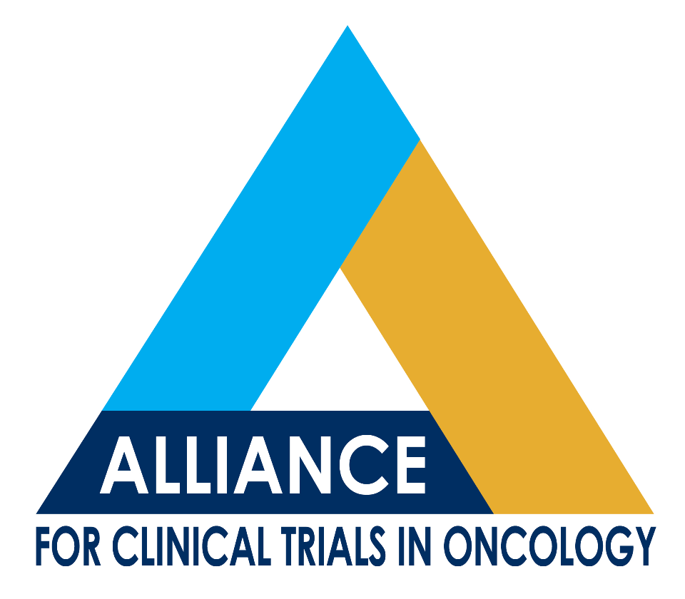
Charles Erlichman, MD, FRCPC, FACP
Co-Director for Experimental Therapeutics Committee
Mayo Clinic
200 First Street SW
Rochester, MN 55905
Phone: 507-266-3200
Email: Erlichman.charles@mayo.edu

Gary Schwartz, MD
Co-Director for Experimental Therapeutics Committee
Memorial Sloan-Kettering Cancer Center
300 East 66th St
New York, NY 10065
Phone: 646-888-4158 Email: schwartg@mskcc.org

Date: October 10, 2013
To: Experimental Therapeutics Committee
From: Charles Erlichman, MD and Gary Schwartz, MD
Re: Experimental Therapeutics Committee Meeting
Friday, November 8, 2013
Time: 8AM-11AM CST
Location: TBD (per agenda for the Alliance mtg)

Call In Information: 800-501-8979 / 8087368

AGENDA
- Status update on activated current trials: (appx. 60 min) Horvath
a. | A091104 | Phase II MK-2206 in Patients with progressive recurrent/metastatic Adenoid Cystic Carcinoma | A. Ho
b. | A091103 | Phase 2 Study of Angiopoitein -1 and -2 peptibody AMG386 for the Treatment of Angiosarcoma | S. D'Angelo
c. | A091102 | Phase II study of MLN8237 in advanced metastatic Sarcoma | M. Dickson
d. | A091101 | TPF Induction chemotherapy and ABT-888- Phase 1/randomized Phase 2 Study in Patients with Locoregionally Advanced Squamous Cell Carcinoma of the Head and Neck | J. de Souza
e. | N1153 | Phase I/II Study of Sorafenib + TH-302 in 1st line Advanced Hepatocellular Carcinoma (HCC) and 2nd line Renal Cell Carcinoma (RCC) | M. Borad
f. | N0871 | A Phase II Study of Carboplatin, Paclitaxel, and RAD001 in previously untreated Patients with Measurable Disease with Cancer of Unknown Primary (CUP) | M. Goetz
g. | N0879 | A Randomized Phase II Trial of Carboplatin, Paclitaxel, Bevacizumab, with or without Everolimus for Therapy of Metastatic Malignant Melanoma | R. McWilliams
h. | N0185 | A Phase I/Feasibility Study of RAD001 plus R-CHOP for New Untreated Aggressive Lymphoma | P. Johnston
i. | A091201 | Randomized Phase II study comparing the MET Inhibitor XL184 to DTIC in Uveal Melanoma | J. Luke

- Status update on current trials in development: (appx. 40 min) Schwartz or Horvath
a. | A091105 | Phase 3 double blind randomized placebo controlled trial of Sorafenib in Desmoid Tumors | M. Gounder
b. | A091302 | Randomized Phase II study of Sorafenib with or without Everolimus in Patients with Radioactive Iodine Refractory Hürthle Cell Thyroid Cancer | E. Sherman
c. | A091305 | A Phase 2 Double-Blind Randomized Study of Efatutazone, an Oral PPAR Agonist, in Combination with Paclitaxel versus Paclitaxel Plus Placebo in Patients with Advanced Anaplastic Thyroid Cancer | R. Smallridge
d. | A091303 | A Randomized Double-Blinded Phase 3 Study of Palbociclib (PD0332991) in Well-differentiated / De-differentiated Liposarcoma | M. Dickson
e. | A091202 | A Phase II Randomized Study of the Peroxisome Proliferator-Activated Receptor Gamma Agonist, CS-7017 (Efatutazone) vs. Placebo in Patients with Previously Treated, Unresectable Myxoid Liposarcoma | M. Pishvaian (GW)

- Status of Concepts: (appx. 20 min) Erlichman
a. | Randomized Phase 2 study of chemo and androgen ablation in salivary gland cancer EORTC 1206 | - Ho (MSK)
b. | A Randomized Phase II Study of MLN-0128 vs. Pazopanib in Patients with Advanced Sarcoma | W. Tap

- New Concepts (appx. 40 min) Schwartz/Erlichman
a. | Treatment of Melanoma | J. Luke

- Central Office updates: Accrual committee, International Committee, Grant results - Horvath (appx 20min)

